GAME NAME  
Cross Platform Development

Author: <Justin / Igor>

Abstract

Top-down zombie shoot em up.

# Change Log

Updates made to the document should be described below.

|  |  |  |  |
| --- | --- | --- | --- |
| Version | Author | Date of change | Description |
| 0.0.0 | AIE | 31/08/2020 | Initial Template created |
|  |  |  |  |
|  |  |  |  |
|  |  |  |  |
|  |  |  |  |
|  |  |  |  |
|  |  |  |  |

Contents

Change Log 1

1.0 Development Environment 3

1.1 Game Engine 3

1.2 Source Control 3

1.3 Third-Party Libraries / assets 3

2.0 Game Overview 3

2.1 Genre 3

2.2 Camera Perspective and Movement 3

2.3 Platform 3

2.4 Technical Goals 4

2.5 Game Objects and Logic 4

3.0 Controls 4

3.1 Windows / Web 4

3.2 Console / Xbox 4

3.1 Android / Touch 4

4.0 Mechanics 4

5.0 Graphics 5

6.0 Audio 5

7.0 Artificial Intelligence 5

8.0 Game Flow 5

8.1 ‘Mission’ / ‘Level’ structure 5

8.2 Objectives/Goal 5

11.0 Interface 5

11.1 Menu 5

11.2 High scores 5

11.3 UI/HUD 5

12.0 Progress report and feedback Meeting Minutes 6

Friday 4th September 6

Wednesday 9th September 6

Thursday 10th September 6

Friday 11th September 7

# Development Environment

## Game Engine

Unity 2019.3.6.f1

Chosen Unity due to its ease of access and beginner friendly interface. The version chosen was selected to the version being constant among all computers on campus.

## Source Control

Link to GitHub repo: <https://github.com/JustinKatic/CPD-TopDownShooter>

## Third-Party Libraries / assets

|  |  |  |
| --- | --- | --- |
| Asset Name  License | URL | Reason for use |
| Character Pack: Zombie Sample  Free – Unity Extension Asset | <https://assetstore.unity.com/packages/3d/characters/humanoids/fantasy/character-pack-zombie-sample-131604> | Enemy asset use for enemy entities in game |
| Jammo Character | Mix and Jam  Free – Unity Extension Asset | [https://assetstore.unity.com/packages/3d/characters/jammo-character-mix-and-jam-158456#reviews](https://assetstore.unity.com/packages/3d/characters/jammo-character-mix-and-jam-158456%23reviews) | Character asset use for main player in game. |
| Weapon Master-SciFi Weapon.1 Lite  Free – Unity Extension Asset | <https://assetstore.unity.com/packages/3d/props/weapons/weapon-master-scifi-weapon-1-lite-134423> | Character’s weapon asset |
| Glossy Bubbles  Free – Unity Extension Asset | <https://assetstore.unity.com/packages/2d/gui/icons/glossy-bubbles-114601> | Bullets |
| Dungeon - Low Poly Toon Battle Arena / Tower Defense Pack  Free – Unity Extension Asset | <https://assetstore.unity.com/packages/3d/environments/dungeons/dungeon-low-poly-toon-battle-arena-tower-defense-pack-109791> | Game Arena |
| ArcadeMusicLoop.wav  <https://creativecommons.org/licenses/by/3.0/> | <https://freesound.org/people/joshuaempyre/sounds/251461/> | Game scene background music |
| Potions, Coins And Box Of Pandora Pack  Free – Unity Extension Asset | <https://assetstore.unity.com/packages/3d/props/potions-coin-and-box-of-pandora-pack-71778> | Health Potion asset |
|  |  |  |
|  |  |  |
|  |  |  |
|  |  |  |
|  |  |  |
|  |  |  |

# Game Overview

Elevator pitch

## Genre

3D Top down Shooter

## Camera Perspective and Movement

Top Down Camera Perspective with rigid body velocity movement

## Platform

what are the requirements for deployment to each platform?   
Setup process has been outlined and detailed >

PC -

Android – Unity Android build, as well as correct SDK paths,

Web -

Xbox -

## Technical Goals

* Goal
* Goal
* Goal
* …

## Game Objects and Logic

A list of logical elements in the game, i.e. door, button, pistol, ammo, light, bullet, wall, character etc. and description of their behavior and purpose

Android – Controlled by the player.

Zombie – Walks towards the player.

Gun – Used by the player to shoot zombies.

Shotgun – Weapon powerup dropped by the boss zombie and collected by the player. Increases player firepower.

Health pack – Fills the players health. Dropped by big green zombie upon death.

# Controls

## 3.1 Windows / Web

**Keyboard**

W - Move Player Character forward.

A - Move Player Character left.

S - Move Player Character backwards.

D - Move Player Character right.

**Mouse**

Left Click - Shoot bullet.

Mouse movement-Rotate player to face towards mouse position.

## 3.2 Console / Xbox / PS4

**PS4 / Xbox analog sticks**

Left analog stick - Move player character in direction of left analog stick.

Right analog stick - Rotate player to face in direction of right analog stick.

-Shoot in direction right analog stick is facing.

## 3.1 Android / Touch

**Android joysticks**

Left Joystick - Move player character in direction of left joystick.

Right Joystick - Rotate player to face in direction of right joystick.

- Shoot in direction right joystick is facing.

# Mechanics

A list of intended core game mechanics. I.e., what the player can do and how they achieve this, and what this will trigger in the game. For example, shooting enemies is a core mechanic in an FPS.

* **Shooting**

Instantiates a bullet from an empty object which is a child of the player so we can get the same rotation and direction the player is facing to ensure the bullet is projected in the correct direction. It has a gun controller script attached. This script contains a bullet speed variable and a time between shots. It also allows us to drag in which bullet we would like to shoot which comes with its own script attached to the bullet which contains a bullet life time that will destroy the bullet after it has been instantiated after x seconds and a damage to give variable which is how much damage the bullet is going to deal.

## Hazards

Throughout the map there are circle platforms placed which is an indication of where the enemy spawn points are.

## Obstacles

To Progress to next wave, you need to destroy all the big zombies in each wave however there are lots in mini zombies that may get in your way trying to attack the player. This creates the gameplay of the player always needing to be on the move repositioning and having to shoot through hordes of little zombies to get to the big zombie

## Items / Collectables

Shotgun – When a boss zombie is killed, it will drop the shotgun which can be collected by the player. The player’s firepower will be increased from one stream of bullets to five. This will allow the player to better cope with the increased number of zombies.

Health Pack – When a big green zombie is killed, it will drop a health pack. Collecting this will fill the player’s health.

# Graphics

Describe graphics features here. I.e., is your game top-down 2D? What post processing are you using? Include perspective, art style, graphic features. Justify graphics selection.

The game is a top-down shooter with 3D graphics.

The art style for the arena is low poly.

A low poly art style for arena was chosen to allow for better performance in other areas due to the low graphical footprint. This is especially important when it came to our mobile platform.

# Audio

Describe audio requirements. Sounds Effects, Ambient music etc.

Background music is a 16 bit retro arcade type tune.

# Artificial Intelligence

Zombies simply walk towards the player. They have no other behavior.

However, each zombie has different attribute values for health and speed, as well as varying in sized to distinguish which zombies are which and how they behave.

Small zombie – 1 hp low move speed

Medium zombie – 20 hp low move speed

Red zombie – 1 hp fast move speed

Giant zombie / Health zombie – 50 hp medium move speed

Boss zombie – 300 hp high move speed

# Game Flow

## ‘Mission’ / ‘Level’ structure

If applicable. Are all levels stored in memory? what data is saved across levels, are levels loaded synchronously to prevent pauses?

There is only one level.

However, high scores are saved to the device.

## Objectives/Goal

What does the player try to accomplish on each level/mission? How is the players progress evaluated?

The players objective in each wave is to get kill all the big zombies while avoid being killed themselves. Killing all the big zombies results in the next wave beginning. The goal is to try and get to the highest wave possible.

1. Levels

If any of the Levels require specific behaviors, describe those here. UML chats provided if applicable.

Level tiling tool use identified if relevant, use by designer discussed, how was it built

There is one level. It is an open arena in the shape of a square which is bounded by walls on each side. The player can move anywhere on the level, except past the walls. There are no obstacles.

# Interface

Make sure to address the differences needed per platform.

## Menu

What are the menu options, how is it presented to the player? Provide wireframe.  
How does this work for each input device chosen (keyboard/mouse, controller, touch)

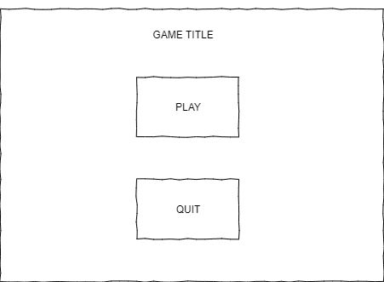

All menu buttons and pause screen buttons are navigable over each device we plan to release for.

Windows – mouse click the button or use ‘W’ and ‘S’ to highlight button and “Enter” to select.

X Box – Left joystick up and down to highlight button and ‘A’ to select.

Android – Tap on screen button to select.

## High scores

how is it presented to the player? Provide wireframe.  
How does this work for each input device chosen (keyboard/mouse, controller, touch)

The current high score is shown in game under the current score. its also displayed again in the Game over screen.

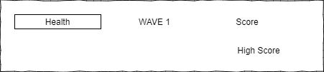

## UI/HUD

What is involved in the UI/HUB, what information is being provided to the player. Mock up of intended UI/HUD design

Windows, Web and XBOX UI:

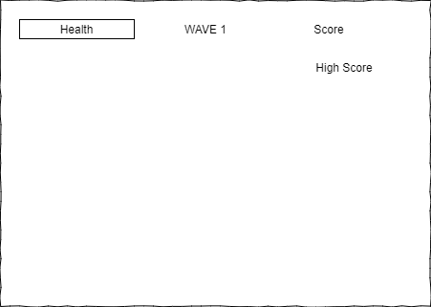

Android UI:

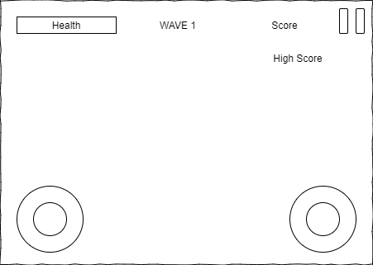

Game over UI:

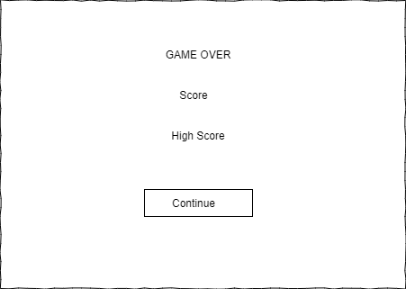

# Progress report and feedback Meeting Minutes

## Friday 4th September

Describe state of project

* Basic game implemented. Player can move around the arena and shoot zombies.
* Player can pick up shotgun weapon and health pack.
* Can play on web, android and windows.

Feedback from teacher and peers:

* Remove quit button on mobile and web
* Fix scale of objects
* Fix health bar scaling
* Fix flying zombies

Action Items:

* Objects have been scaled
* Health bar filter mode changed to Point

## Wednesday 9th September

Describe state of project

* Basic game implemented. Player can move around the arena and shoot zombies.
* Player can pick up shotgun weapon and health pack.
* Can play on web, android and windows.
* High scores now saving

Feedback from teacher and peers:

* Fix inverted web controls.
* Remove quit button on web

Action Items:

* Web controls fixed.
* Web button removed.

## Thursday 10th September

Describe state of project

* Thing
* Thing

Feedback from teacher and peers:

* Zombie damage indication.
* Describe
* Describe

Action Items:

* Zombie blood effect on bullet hit.
* Describe
* Describe

## Friday 11th September

Describe what has been done since last time

* Thing
* Thing

Feedback from teacher and peers:

* Describe
* Describe
* Describe

Action Items:

* Describe
* Describe
* Describe